CHANGE OF DATE AND VENUE
YEAR END LUNCH
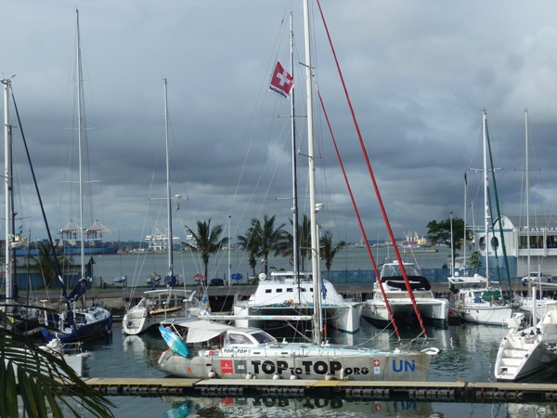
SATURDAY 3RD DECEMBER 2011 12h00
POINT YACHT CLUB - VICTORIA EMBANKMENT
PRESENTATION AND LUNCH 1ST FLOOR
- 11h00-11h30 Presentation by Dario Schwörer
- 12h00-14h00 Buffet Lunch R 95.00 per adult and children up to 12 years of age R 47.50
- 14h00 Visit by Father Christmas (please bring little present with name tag for children)
- 15h30 Closure and opportunity to visit expedition boat.
Please book urgently (indicate children):
Philippe Lanz 031 – 765 1625 082 – 493 2673

