The Swiss “TOPtoTOP Global Climate Expedition”
under the patronage of United Nations Environment Program and Switzerland
arrived in Richards Bay, South Africa on the 4th of November 2011 and is now in Durban attending the World Climate Conference.

The expedition is achieving a world record, by being the first to travel all climate zones - over the seven seas to the seven summits - using only human force and nature’s power! This to set an example what can be done to live in harmony with our climate.
TOPtoTOP is sharing the collected climate solutions to students along the way and motivate them to participate in the “TOPtoTOP Climate Solution Award”. The winner in each continent is rewarded to become a TOPtoTOP ambassador and invited to study the best practice examples in Switzerland in 2013.

The Swiss family Schwörer are the core expedition team members. The 4 children were born on the expedition. Alegra the youngest crew on board is only 5 months old. Already volunteers from 42 nations were joining the family. They are engaged in educational activities with schools and universities, inspiring the use of “Swiss innovations for a green planet”. So far the family sailed 42’613 nautical miles in their expedition vessel, climbed over 400’000 vertical meters, cycled over 18’000 kilometres and visited over 50’000 students!

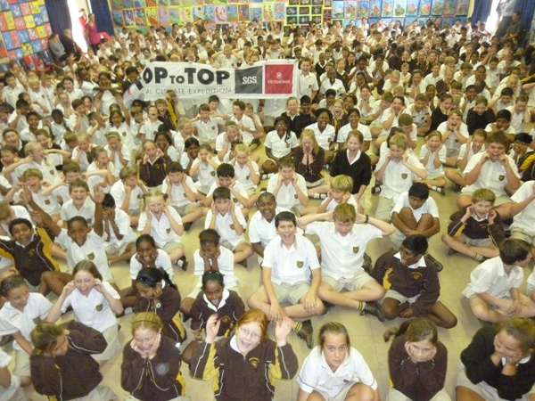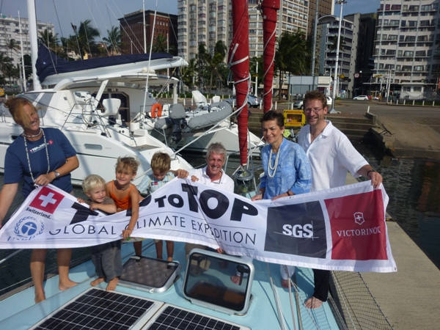
Already more than 800 students visited in Durban Christiana Figueres on Pachamama

The family sailed into Richards bay from Reunion Island with 3 Swiss volunteers on board and organized together with the office of KZE Agriculture, Environmental Affairs and Rural Development, an awareness walk on the 18th November 2011 to start the 10 days count down towards the COP 17 climate conference in Durban.
Around 200 people showed up and expressed themselves nice African songs about protecting the environment. After planting two trees the mayor and Dario gave a speech about how important it is to protect our climate.

“Before our arrival in South Africa we were scared from the rumours about crime in this part of the world. But since now we saw only nice hospital people and we already became fan about this wonderful country. All fears about crime diapered and we are enjoying the people and country,” says Sabine.

“On the 19th of November we used a short weather window and left Richards Bay and set sail towards Durban. Since Monday 28th November the annually climate conference is taking place in this green city. There are delegations from 192 countries hoping to bring the new protocol that will replace Kyoto-Protocol an important step further. Next to the Durban ICC, where the politicians try to find consents in environmental questions there is an exhibition side open to the public. All around the side there are lot of nice places to eat to watch African performances or to see innovative solutions for a greener future. TOPtoTOP is part of the official Swiss presentation in the International Exhibition tent, where we offer interesting presentations and speeches. The Swiss expedition sailboat is only a 15 minutes walk away at Point Yacht Club.

In the first week of the conference we had a hand over of 2'710'340 green footprints from 201'146 kids to the "highest UN climate protector", Christiana Figueres, Executive Secretary of the UN Framework Convention on Climate Change (UNFCCC). Together with her husband she joined us to have breakfast on our sailboat Pachamama the next morning. They came cycling from the conference and spent 2 hours on board. Christiana and her husband Konrad von Ritter were very impressed about this Swiss initiative and put their credits in the "Golden Book" of the expedition.

Because we have good media coverage, there are a lot of people coming to see the unique Swiss sailboat. It stands for THE example in the sailing world what can be done with renewable and smart technologies. But not only visitors are keeping us busy: My wife and nurse Sabine cured some police divers who got sick while diving in a sewage tunnel under the ICC (conference) the day before controlling for bombs...and just now there is an Indian couple taking wedding pictures on the front deck after asking permission to do so...they like the idea of a unique boat on their unique day...

After 10 years on the Swiss Climate expedition and making all the way from Switzerland to Durban walking, cycling and sailing, we are looking forward to welcome Doris Leuthard, minister for the environment on Pachamama. It will be a great honour and like Xmas for all members and volunteers who never gave up to inspire the students with all the positive climate solutions.

COP17 is a highlight for me: To see so many people they act and care about our global climate is a great experience. We will see next week how capable politicians are to transform it into policies. I believe like a Ocean crossing it takes a while...but important is that we are on course! Keeping the course brought us finally to South Africa. We needed all our effort and strength to hand steer, day and night over weeks till we were rewarded to see the harbor entry of Richards Bay at the horizon. The course is set and I am sure that we will challenge and face global warming and finally find a solution to climate change.
We can be proud of our small country Switzerland; - sailing the world and connecting all climate zones, I can say that it’s still the champion when it goes to renewable technologies and climate protection! – Dear reader, let’s start today with a small thing that helps our climate, so that our children can be proud Swiss citizens in the future too. Please write your commitment for the climate that we can publish the first great ideas and commitments already in the next Swiss Review.

Finally I like to thank you Honorary Consul Hanspeter Graber for his great organisation skills:
On Tuesday he organized a dinner for the discussion group of countries where Switzerland is part of it. Members from the delegation of Lichtenstein, South Korea, Monaco and Mexico and Switzerland visited Pachamama and enjoyed a presentation about the expedition at the Royal Natal Yacht Club.
On Saturday the local Swiss Club was invited for a presentation and visit of the boat at the Point Yacht Club. Even Santa from the North Pole showed up! Bravo Hanspeter!”; says Dario.

Swiss Expedition sailboat Pachamama in Port
November 20 - December 15 | Royal Natal YC, Durban, South Africa
December 23 – January 15 | Simons Town, South Africa

Info about the expedition:

TOPtoTOP Global Climate Expedition began in 2002, and is a non-profit organisation of volunteers from 38 nations, based in Switzerland, under the patronage of the United Nations Environment Program and the Swiss Government. The yacht, PACHAMAMA, (Incan word for “Mother Earth”), is equipped with 11 Solar Panels and 2 Wind turbines, making it THE example for the cruising world, demonstrating what is possible in extreme conditions with smart renewable technologies. After more than 10 years on their mission, the team just arrived Richards Bay hand steering from their last destination Mauritius after the autopilot broke down. They had braving harsh conditions so as to reach South Africa in time for the COP17 in Durban. There they demonstrate TOPtoTOP as a platform for young people to express their ideas and solutions for climate protection and contribute an important message to the conference.

This unique initiative is based on environmental sustainability and to prove that great things can be achieved in balance with nature. The goal of the expedition is to bring awareness of environmental issues, to promote the search for environmentally compatible solutions and to encourage the start of projects beneficial to our climate.

A major part of their mission is to inspire children to achieve a better future. They share examples of nature’s beauty and innovations for a green planet in class rooms all over the world and also give presentations to universities, service clubs and other organisations throughout the world. Already, they have taught over 50,000 children across the globe! They teach students about the importance of nature and give them various fun projects to learn all about sustainability. The students are then encouraged to express their own ideas about how we can care more for our environment and climate in the TOPtoTOP International Climate Solution Contest. TOPtoTOP aims to show case this solutions from the youth at the conference in Durban.

TOPtoTOP has chosen this expedition as an adventurous means to create awareness of global climate change and inspire the world to research and support lasting, environmentally friendly solutions. To expand the reach of this expedition and its aim, TOPtoTOP is working closely with the media, scientists and business worldwide.

Another aspect of the initiative is the clean ups. They have done clean ups at each of their destinations. The last TOPs they cleaned from trash was the top of EVEREST and Kilimanjaro. On the current voyage have cleaned beaches in Malaysia, Cocos Keeling (Australia), Mauritius and La Reunion. It is estimated that the TOPtoTOP expedition has collected 25 tonnes of waste so far!

All these achievements would never have been made possible without the generous support of their sponsors, particularly their two major sponsors SGS and Victorinox. SGS and Victorinox have both been actively involved in keeping PACHAMAMA ready for this incredible voyage. Their support as well as the patronage of the United Nations Environmental Program and Presence Switzerland is a crucial aspect of the success of the TOPtoTOP expedition. Both companies and organizations are great examples of institutions that are increasingly embracing the principles of environmental sustainability in their planning, reporting and decision-making.
In South Africa they already experienced excellent support and hospitality through the “Peri Peri” weather service Zululand Yacht Club, Royal Natal Yacht Club and Point Yacht Club.

For further information and live updates on the expedition’s progress, please visit the TOPtoTOP website: www.toptotop.org ...and their blog: www.expedition.toptotop.org

To arrange free school visits and public presentations or for film material, pictures and interviews with the team, kindly contact:

Dario Schwörer
Email: dario@toptotop.org mobile:+27 (0)71 3484 971

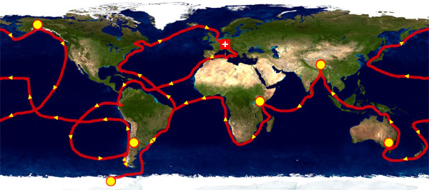
- The expedition aims to demonstrate that great goals and progress can be achieved in balance with nature.
- The mission is to inspire young people for a better future. Along the expedition we show examples of nature’s beauty and promote innovations for a green planet and specially to protect our climate, in class rooms all over the world.
- The key messages are "climate protection" and "enjoy nature through sport but also give something back to nature".
- The vision is that TOPtoTOP becomes a lasting platform which brings active people closer to nature and sports.

